**Resume Generator**

1. Create new skelaton

-> *composer create-project symfony/website-skeleton resume_generator*

1. I used server to execute (**php bin/console server:run**)

-> *composer require server --dev*

1. Created a controller
2. Generate user Entity
3. I made the migration to database with doctrine, I used *mariaDB* with *WampServer* where I added user for examples

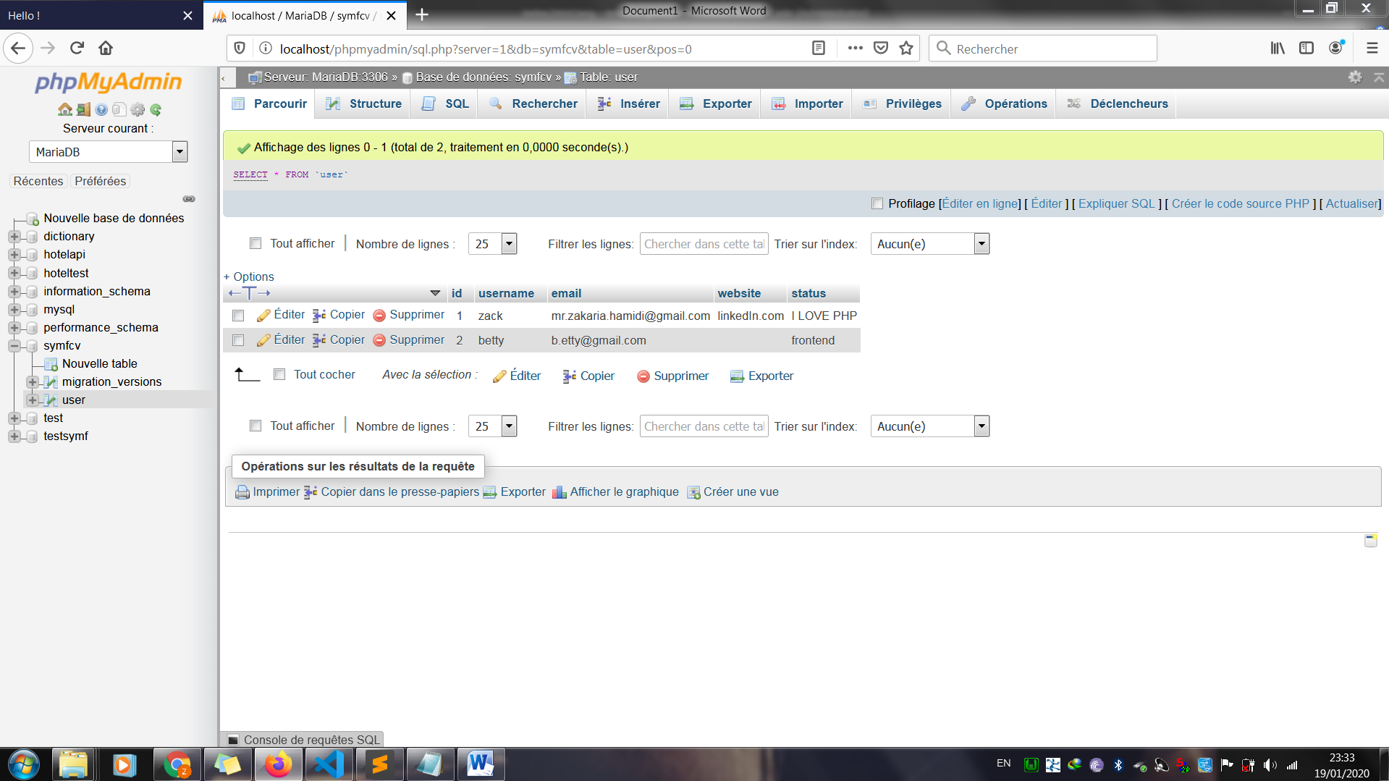

1. I created a method to generate the form and redirection with username as a POST request
2. I used twig
3. I used validator constraints as assert so any user can’t generate the resume without typing at least 5 characters

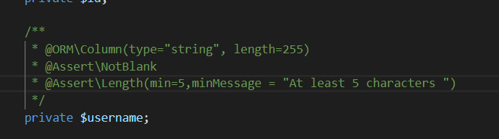

1. I made a condition if the user exist then it will generate the resume otherwise it will show a message that he doesn't
2. Condition if web site exists by using «not empty»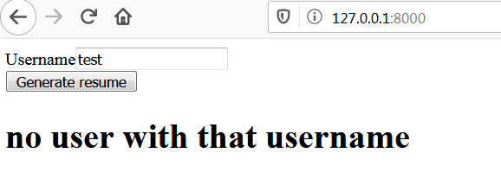

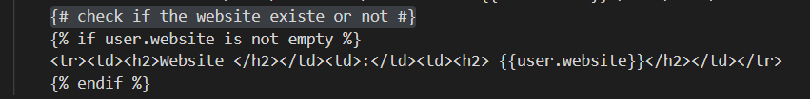

1. Go back link to refresh and go back to generate another resume
2. I added Language entity with a relation ManyToOne to our User entity

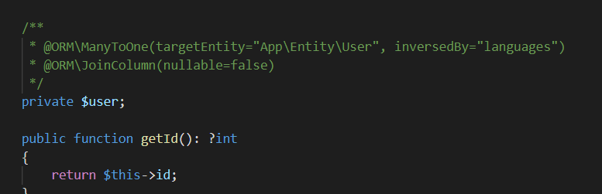

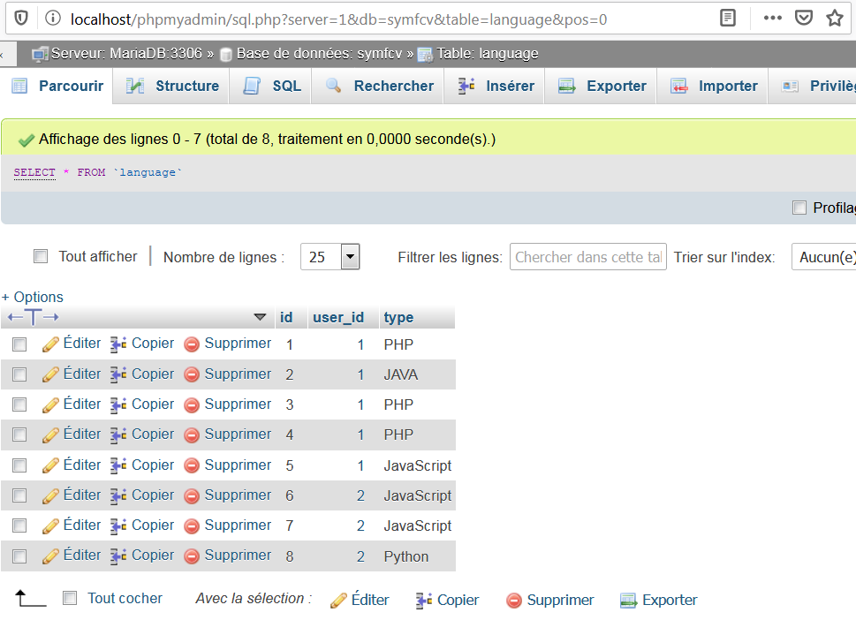

1. I had to use twig to remove get unique languages ( remove duplicated languages)

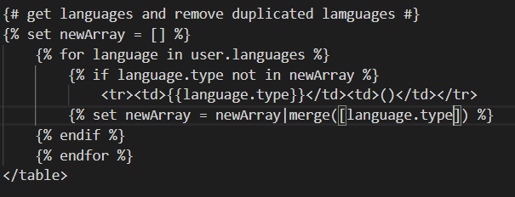

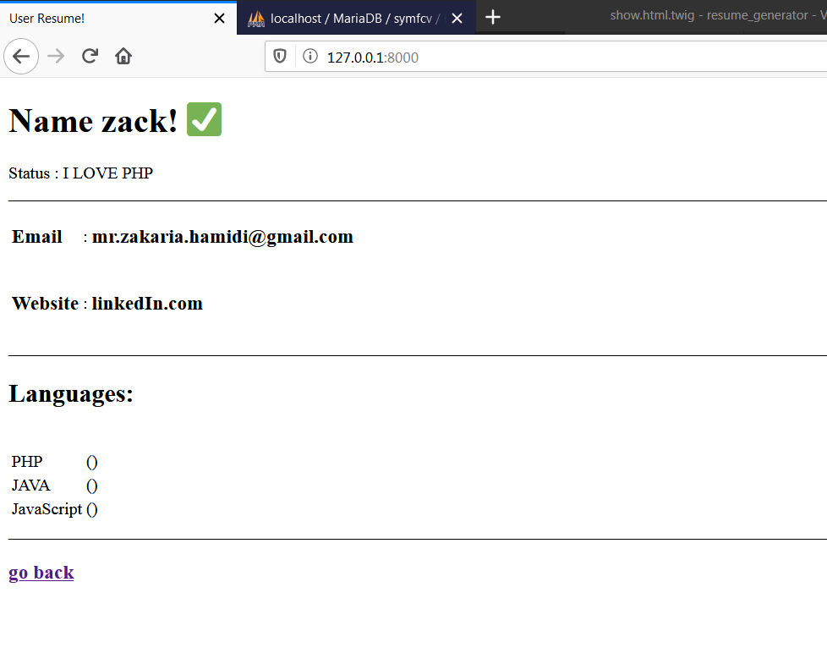

1. I used twig conditions and loops to count how many time the languages were used, I used round to ceil the percentage

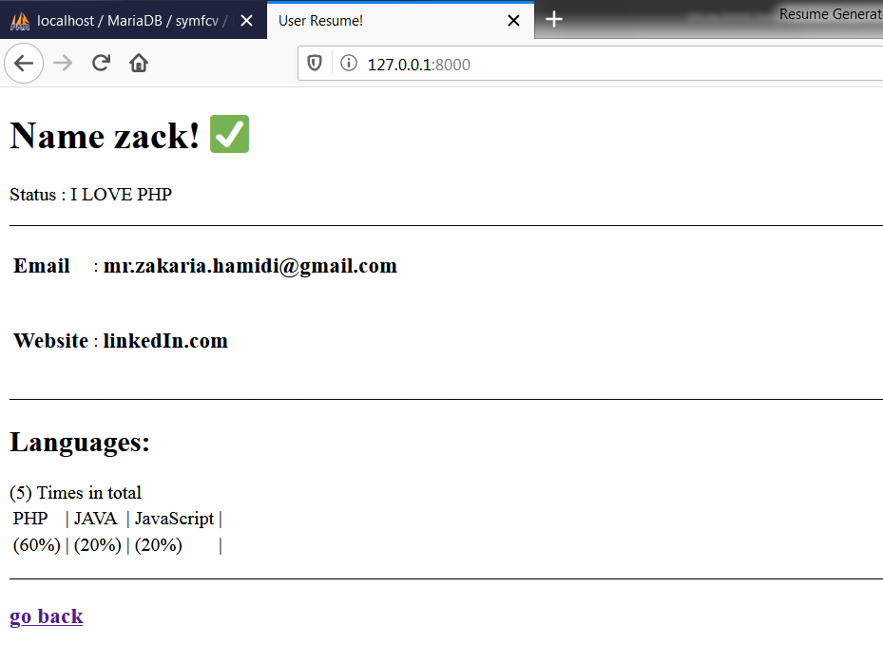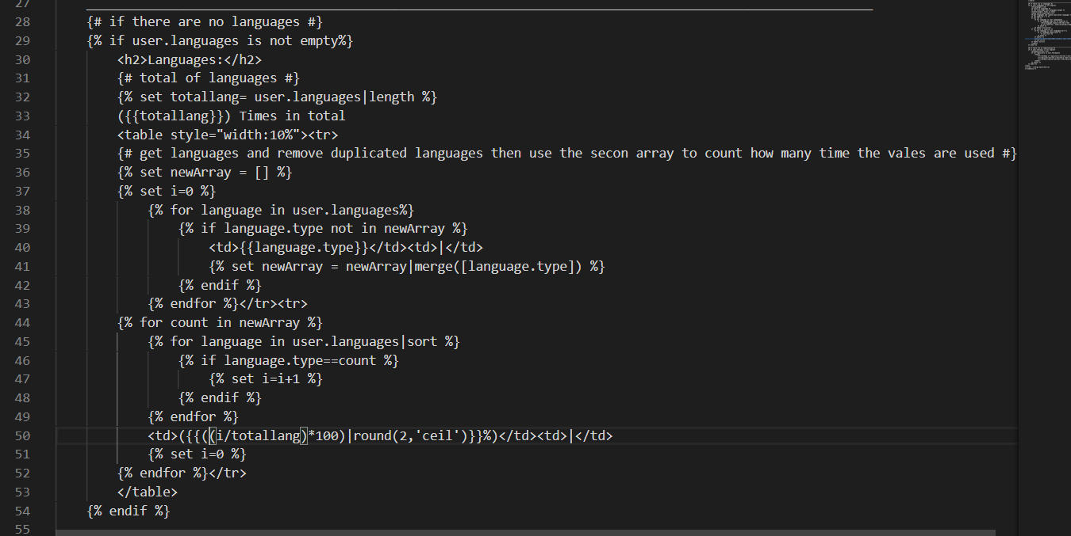

1. I created The repository Entity
2. Then I did the same as Languages, relation with user, after that I inserted data in DB
3. I added a condition if there are no languages or repositories they won’t appear

First example

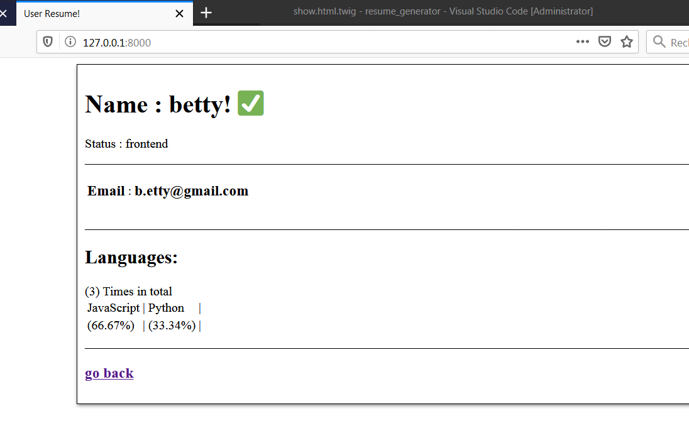

Second example and the whole realization

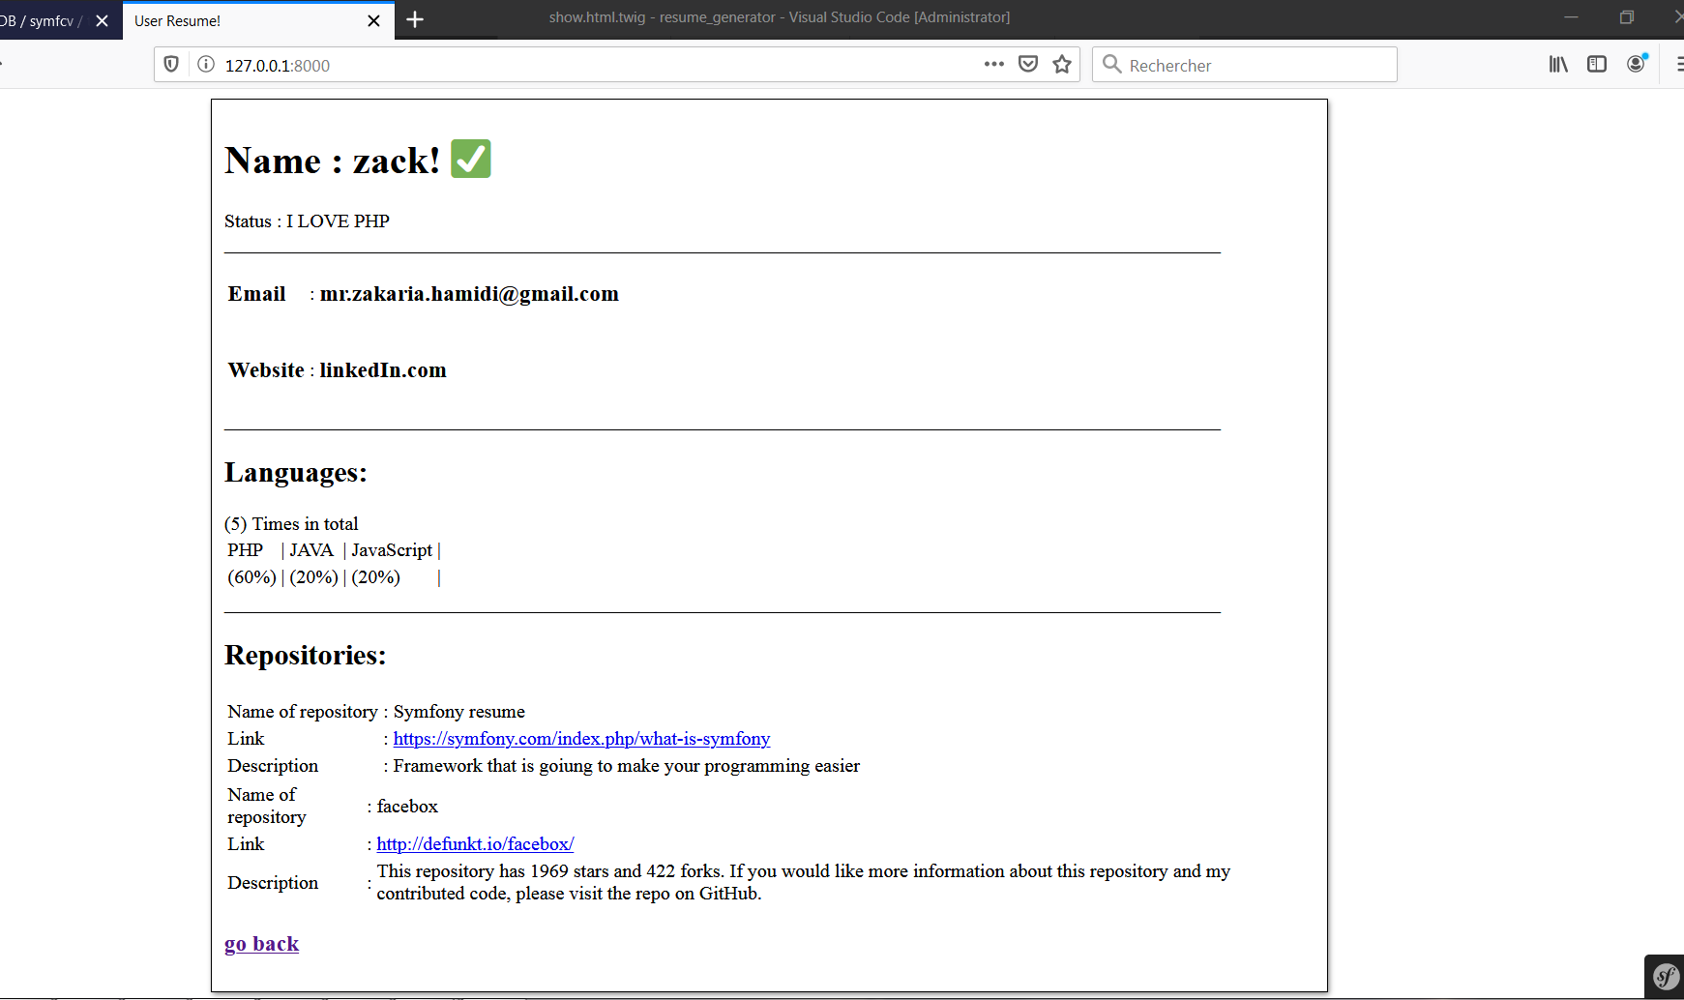**Thank you for your Time**

Waiting for a positive feedback, I am looking forward to discuss the code with you and get to the next step of recruiting process.